Name: Vinay Yadav  
Username: vinay_gitti

URL:

<https://github.com/vinay-gitti/freshersbatch-oct16.git>

Screenshots:

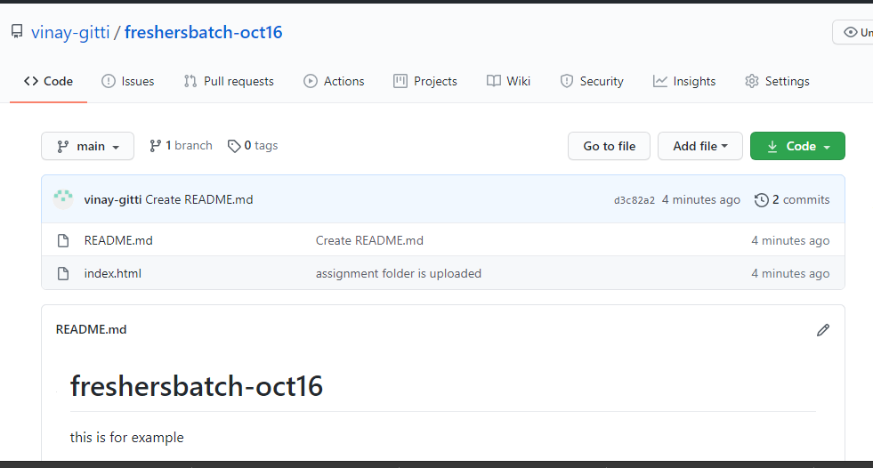

Files in my laptop:

